**GitHub Installation Documentation**

Make a GitHub Account before proceeding with the installation

**Step 1:** Download GitHub desktop from –

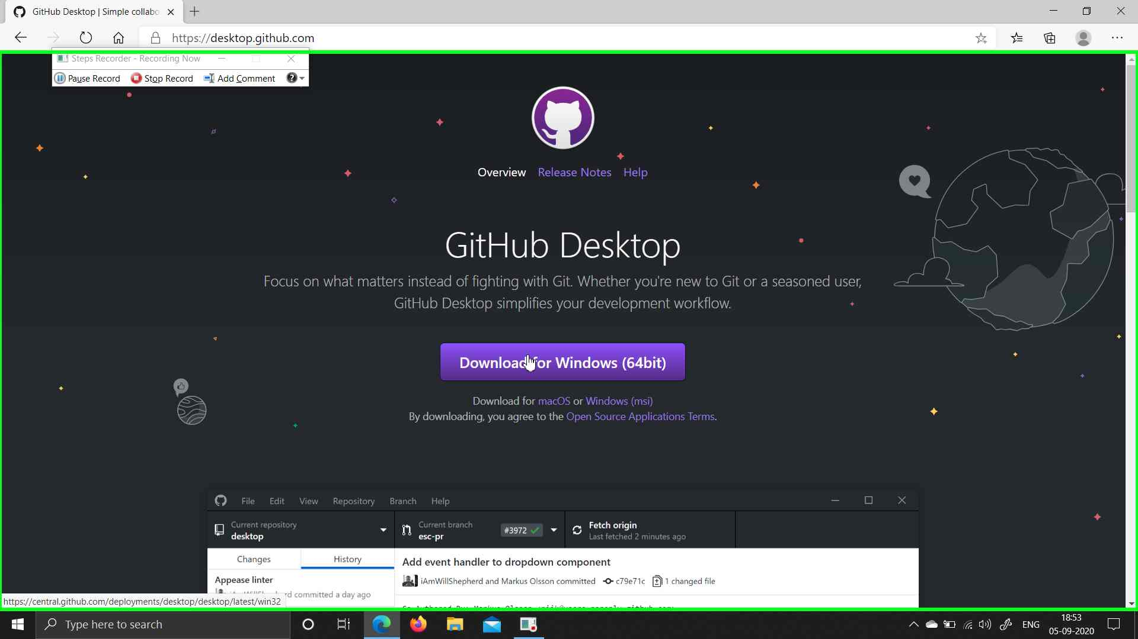

**Step 2:** Open Setup Files

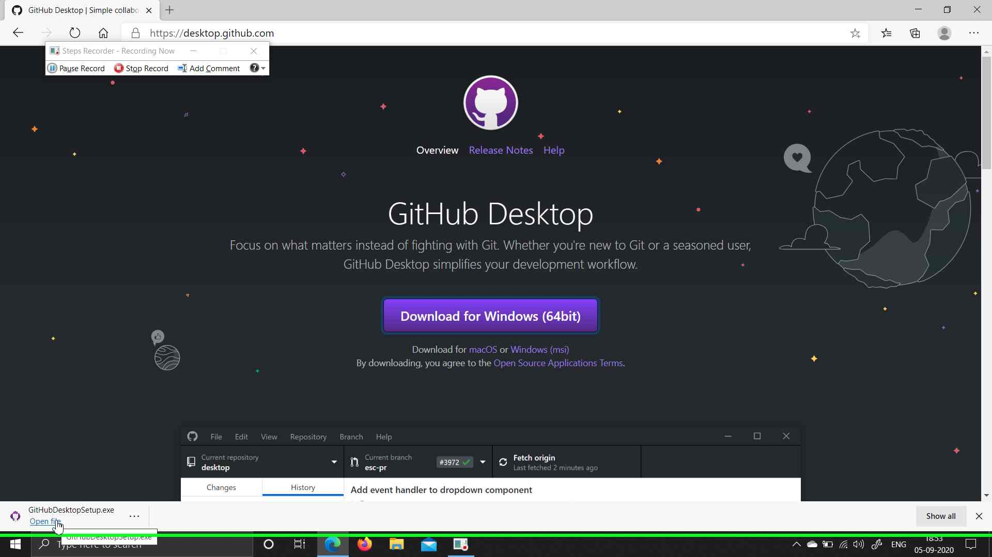

**Step 3:** Click “Sign in to GitHub.com”.

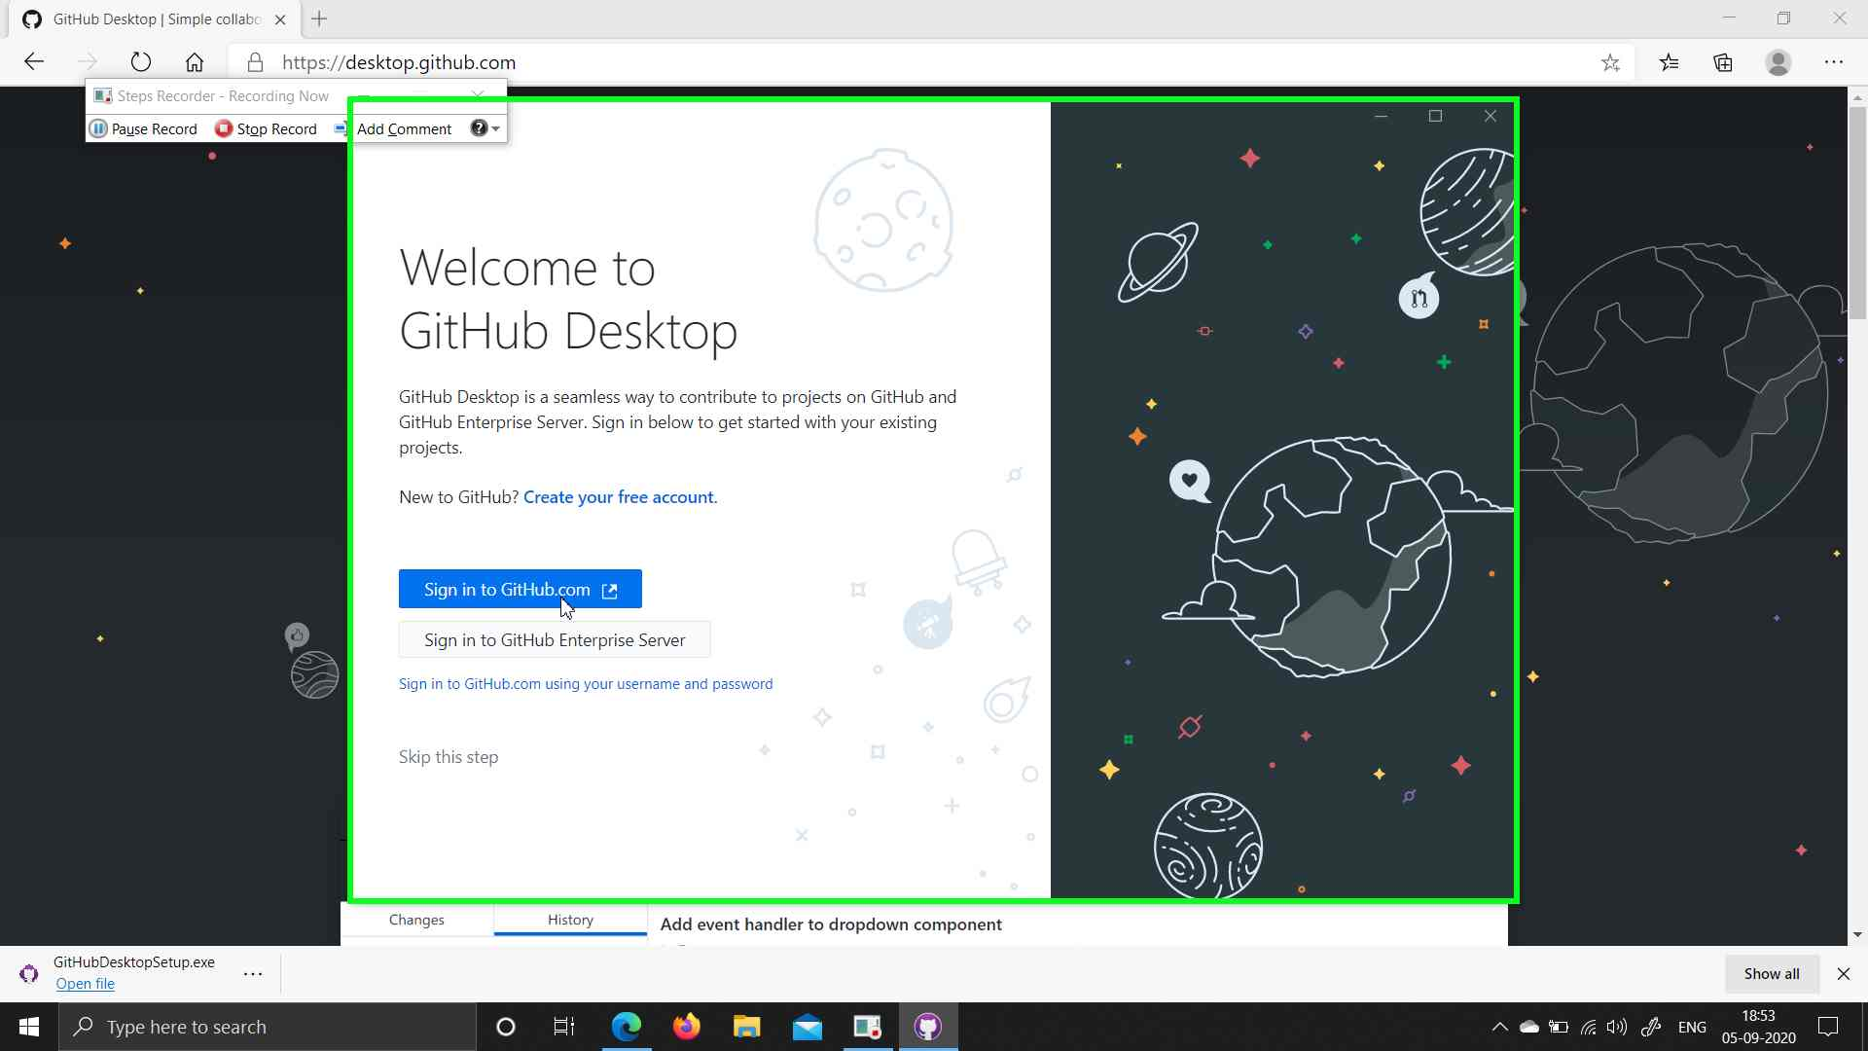

**Step 4:** Enter your username and password and sign in

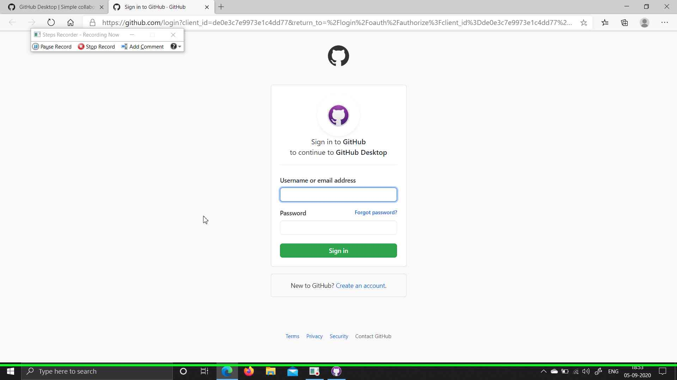

**Step 5:** Click on “Open” in the browser alert.

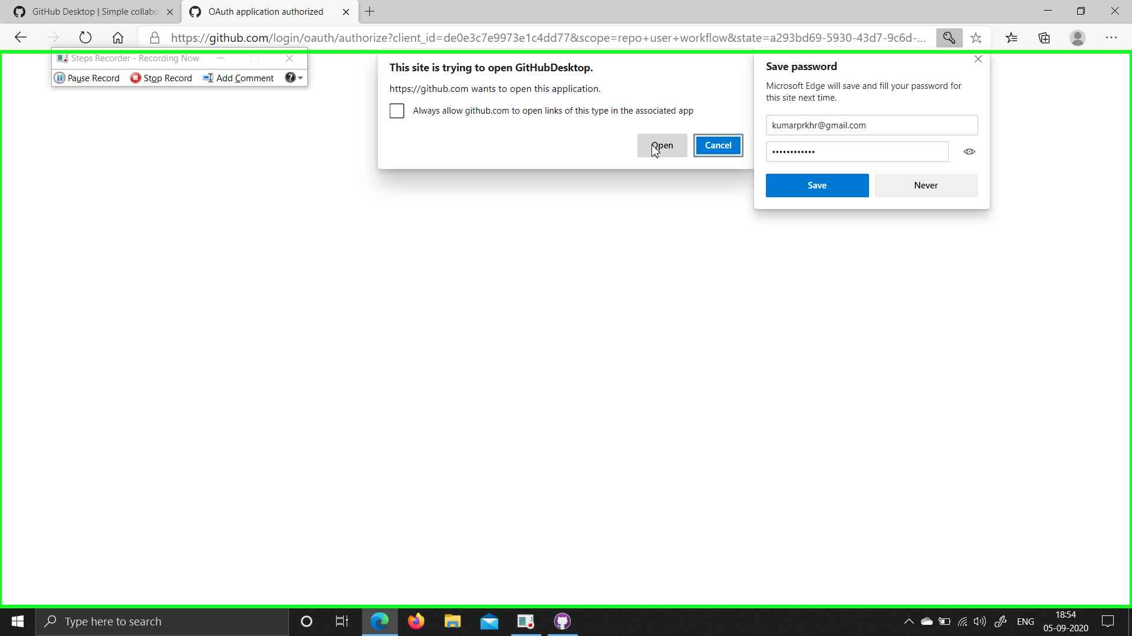

**Step 6:** Click on "Continue (button)"

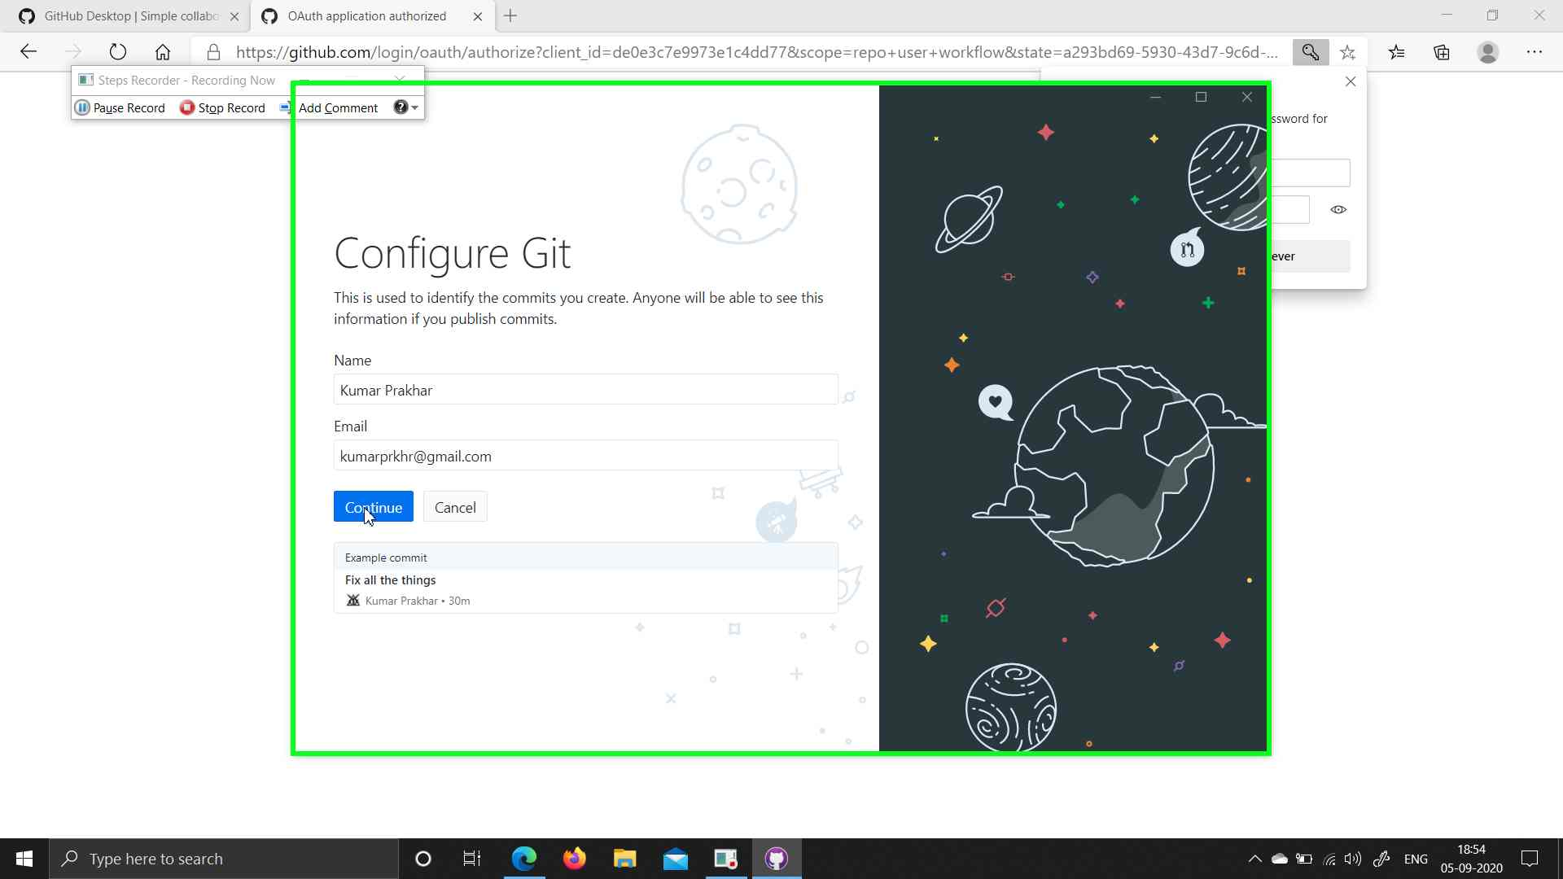

**Step 7:** Click on "Finish (button)"

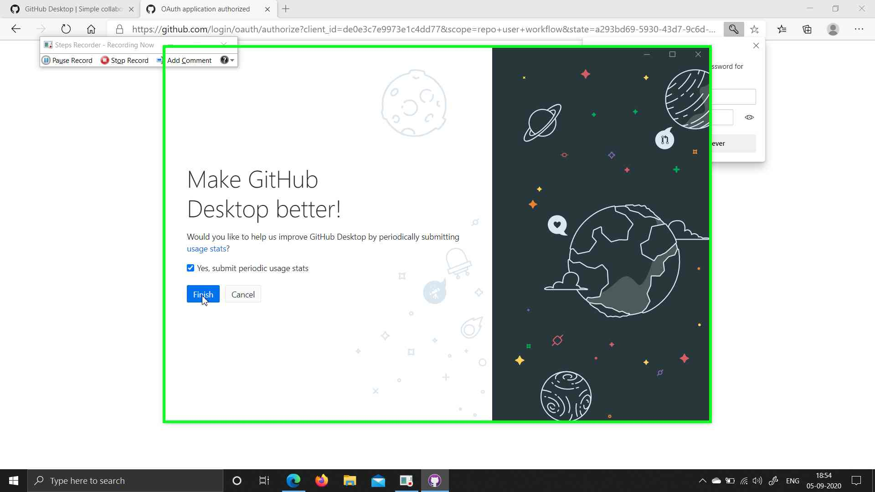

Next

**Step 8:** GitHub desktop is ready

